**Project Proposal: The Effect of Temperature and Snow Cover Change on Snowy Owl*, Bubo scandiacus,* Migration Range**

Group 6: James Alexander, Christiane Newcombe, Willem Pretorius, Jude Slater

Department of Integrative Biology

BIOL*4110 Ecological Methods

Dr. Joey Bernhardt

October 10th 2024

**Introduction**

Anthropogenic climate change has been linked to widespread shifts in species' geographic distribution and migratory behavior. Migratory birds are especially sensitive to these shifts in temperature. Though responses vary amongst species, generally, climate change has resulted in latitudinal range shifts north (Rushing *et al.*, 2020). Snowy Owls, (*Bubo scandiacus*) a migratory bird with an extensive range (Fink *et al.*, 2022), could provide important insight into these shifts as future variations in climate could potentially affect their habitat and survival. Due to the often irregular nature of snowy owl migration (Fuller *et al.*, 2003) there remains uncertainty regarding the effect of climate change on the species. This study addresses this gap by examining the relationship between temperature sensitivity and Snowy Owl migration, offering broader insights into ecological patterns influenced by climate change. We ask the question how do increasing temperatures and decressing snow cover in breeding and non-breeding ranges affect the geographic range of Snowy owl, migration in Canada? Our hypothesis posits that increasing temperatures and decreasing snow cover, in both breeding and non-breeding ranges will shift the geographic range of Snowy owl migration. We predict that when temperatures are warmer snowy owls will shift breeding and non-breeding ranges northwards. Additionally, we predict that decreasing snow cover in southern latitudes will result in a northward shift for the species.

**Methods**

For our analysis, we are using two data sets: (1) An eBird data set consisting of snowy owl observations across Canada with effort data associated with each observation, and (2) a Climate data set from the Canadian government that contains temperature, snow cover, and other climate variables for individual weather stations across the country. The raw eBird data has 58331 observations, and the weather data has 1911 weather stations. Both the eBird and weather data will be grouped into latitudinal ranges that cover the normal distribution of the snowy owl in Canada. The latitudinally grouped data will only have data during the time of year that snowy owls are present in that latitude (breeding or non-breeding). The breeding season includes the months of May through September, and the non-breeding season will be October to April. The eBird data will be used to model the relative abundance of snowy owls for each range individually by year using methods described in eBird best practices (Strimas-Mackey *et al.*, 2023). A general abundance model (GAM) that uses time, distance, and number of observers as effort data to create a GAM formula. The GAM formula distribution needs to be tested and a model will be selected accordingly. The climate data for all latitudes will then be combined with each latitude data frame of eBird data within the same year. This data can then be used in a multiple linear regression to test the correlation of climate at all latitudes/seasons to relative abundance of snowy owls at a particular latitudinal range in their breeding and non-breeding seasons (Figure 1.). To test for potential lag in abundance after climate variable changes in previous years, the same multiple linear regression will be performed with abundance lagged behind different intervals.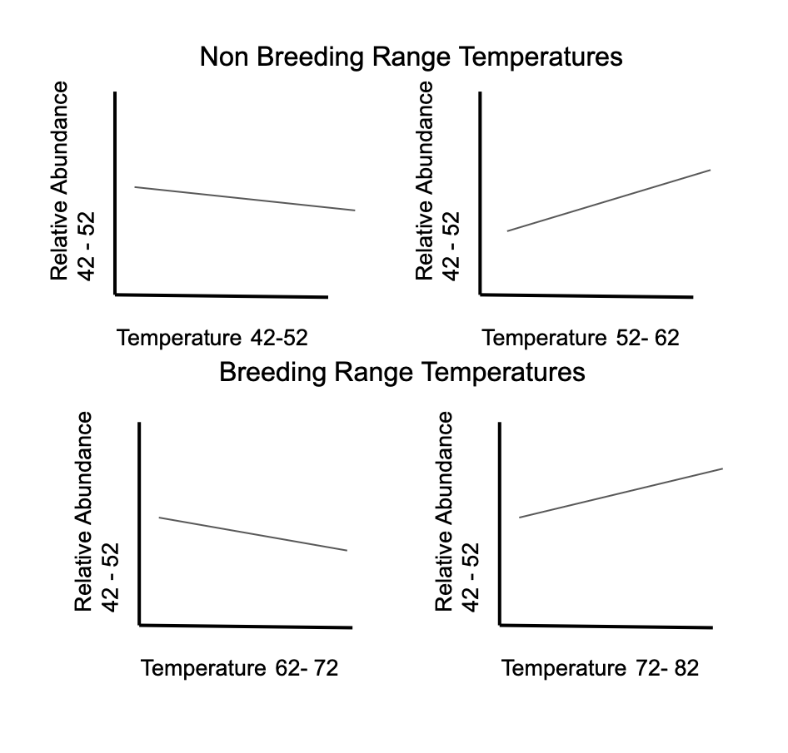

*Figure 1. An example of the output of the graphs from one of the multiple linear regressions. Abundance at 42-52.*

**Anticipated results**

Anthropogenic climate change, increasing temperatures and shifting snow distribution have led to a northward range shift for owls (Curk *et al*., 2020) (Van Brempt *et al*., 2023). Relative abundance of snowy owls is expected to move to higher latitudinal migration ranges in all months, regardless of breeding status. Table 1 shows abundance at breeding and non-breeding months shifting upwards from previous non-breeding and breeding latitudinal ranges. Studies analyzing snowy owl migratory noted their behaviour as irregular, becoming muddied by prey availability (Fuller *et al*., 2003) (Newton, 2006). Prey availability may drive Snowy Owls’ to lower latitudes if anthropogenic temperature and snow distribution changes are insignificant (Fuller *et al*., 2003) (Newton, 2006). Furthermore, lag analysis is expected to provide insights into how quickly Snowy Owls respond to climate changes, potentially identifying delayed migration responses. Despite migratory changes across months, the latitudinal migration ranges and habitats with the highest relative abundance are expected to shift north.

| Year | Abundance 42-52 | Abundance52-62 | Abundance 62-72 | Abundance 72-82 | Temp 42-52 | Temp 52-62 | Temp  62-72 | Temp 72-82 |
| --- | --- | --- | --- | --- | --- | --- | --- | --- |
| 2007 | 1200 | 500 | 100 | 12 | 0℃ | -3℃ | 5℃ | 2℃ |
| 2009 | 1190 | 510 | 90 | 22 | 1℃ | -2℃ | 6℃ | 3℃ |
| 2011 | 1180 | 520 | 80 | 32 | 2℃ | -1℃ | 7℃ | 4℃ |
| 2013 | 1170 | 530 | 70 | 42 | 3℃ | 0℃ | 8℃ | 5℃ |

*Table 1. Potential changes in abundance and temperature at non-breeding latitudinal ranges (42-52 & 52-62) and breeding latitudinal ranges (62-72 & 72-82)*

**Significance**

Our findings on Snowy Owl migration could provide valuable insights into how climate change is influencing the migratory patterns of other bird species, particularly true owls. As a top predator in Arctic and subarctic ecosystems, the Snowy Owl serves as an important bioindicator of ecosystem health. Changes in its migration patterns due to rising temperatures could reflect broader ecological shifts, impacting prey availability and predator-prey relationships (Root *et al.*, 2003). For instance, mismatches between the Snowy Owl’s migration timing and the availability of its prey, such as lemmings, could reduce reproductive success and destabilize population numbers if prey species do not adjust their ranges at the same rate (Both *et al*., 2009). While our study focuses on Snowy Owls, its findings may have broader implications for the conservation of other Arctic migratory species. From a conservation perspective, these results may emphasize the need for adaptive strategies, such as preserving migration corridors and ensuring prey population stability (Lawler *et al*., 2009). Given the irregular migration patterns documented by Fuller et al. (2003), ongoing monitoring will be critical to assessing the long-term effects of climate change on this species. Finally, this study could highlight the importance of alternative hypotheses, such as the role of prey distribution, or urbanization when analyzing migratory shifts.

**Citation**

Both, C., et al. (2009). Climate change and unequal phenological changes across four trophic levels: Constraints or adaptations? *Journal of Animal Ecology*, 78(1), 73-83.

Curk, T., Pokrovsky, I., Lecomte, N., Aarvak, T., Brinker, D. F., Burnham, K., Dietz, A., Dixon, A., Franke, A., Gauthier, G., Jacobsen, K.-O., Kidd, J., Lewis, S. B., Oien, I. J., Sokolov, A., Sokolov, V., Solheim, R., Weidensaul, S., Wiebe, K., … Safi, K. (2020). Arctic avian predators synchronise their spring migration with the northern progression of snowmelt. *Scientific Reports*, *10*(1), 7220–7220. <https://doi.org/10.1038/s41598-020-63312-0>

Goverment of Canada. (2024). Historical Climate Data: Monthly Climate Summeries. *Government of Canada.* <https://climate.weather.gc.ca/prods_servs/cdn_climate_summary_e.html>

Fink, D., T. Auer, A. Johnston, M. Strimas-Mackey, S. Ligocki, O. Robinson, W. Hochachka, L. Jaromczyk, C. Crowley, K. Dunham, A. Stillman, I. Davies, A. Rodewald, V. Ruiz-Gutierrez, C. Wood. (2023). eBird Status and Trends, Data Version: 2022; Released: 2023. Cornell Lab of Ornithology, Ithaca, New York. <https://doi.org/10.2173/ebirdst.2022>

Fuller, M., D. Holt and L. Schueck. (2003). Snowy Owl movements: Variation on the migration theme. Edited by P. Berthold, E. Gwinner and E. Sonnenschein, Avian migration. Berlin: Springer-Verlag.

Newton, I. (2006). Advances in the study of irruptive migration. *Ardea*, *94*(3), 433–460.

Root, T. L., et al. (2003). Fingerprints of global warming on wild animals and plants. *Nature*, 421, 57-60

Rushing, C. S., Royle, J. A., Ziolkowski Jr, D. J., & Pardieck, K. L. (2020). Migratory behavior and winter geography drive differential range shifts of eastern birds in response to recent climate change. Proceedings of the National Academy of Sciences, 117(23), 12897-12903.

*Snowy Owl—EBird*. (n.d.). Retrieved April 1, 2022, from <https://ebird.org/species/snoowl1>

Strimas-Mackey, M., W.M. Hochachka, V. Ruiz-Gutierrez, O.J. Robinson, E.T. Miller, T. Auer, S. Kelling, D. Fink, A. Johnston. (2023). Best Practices for Using eBird Data. Version 2.0. https://ebird.github.io/ebird-best-practices/. Cornell Lab of Ornithology, Ithaca, New York. <https://doi.org/10.5281/zenodo.3620739>

Van Brempt, M., Weidensaul, S., Brinker, D., Coté, P., Okines, D., Bonte, D., & Therrien, J.-F. (2023). Does migration phenology of Northern Saw-whet Owls (Aegolius acadicus) vary over time? *The Wilson Journal of Ornithology*, *135*(2), 269–275. <https://doi.org/10.1676/22-00080>